Autism Detection Using Machine Learning and Deep Learning

Nawal Ayesha Khan   
1911301042  
North South University   
nawal.khan@northsouth.edu

Sarah Jasim  
1912260042  
North South University  
sarah.jasim@northsouth.edu

Seam E Nur  
1912489042  
North South Universityseam.sami@northsouth.edu

*Abstract*—- In this project, we design an ASD (Autism Spectrum Disorder) classification system using different Machine Learning algorithms to replicate the results in previous studies. The classification algorithms used in this project were SVM classifier and DecisionTree classifier. Based on the results, the SVM classifier gave an overall accuracy of 47, and the DecisionTree classifier gave 56% overall accuracy, thus, producing similar results to those of the studies reviewed in this paper.

# Introduction

Autism spectrum disorder (ASD) is a neurodevelopmental disorder characterized by impairments in social interaction and communication, as well as restricted, repetitive patterns of behavior, interests, and activities [7]. People with ASD may also have different ways of learning, moving, or paying attention.

Clinical diagnosis of ASD is mostly based on medical history, clinical observation, and psychological evaluation, such as combined utilization of ADI-R (Autism Diagnostic Interview-Revised) and ADOS (Autism Diagnostic Observation Schedule). However, behavioral indices like psychological assessment could not get rid of some limitations like subjectivity and reporter-dependency. Hence, researchers have been looking into relatively stable biomarkers of ASD as additional diagnostic evidence. The identification of patterns of activation for ASD and the association of the patterns with neural and psychological components contribute to the understanding of the etiology of mental disorders, and the use of Deep Learning and Machine Learning algorithms has helped substantially in these regards. Most papers have looked into using more computationally intensive algorithms like Support

Vector Machines, K-means clustering, Random Forest Classifiers, or Neural Networks. Our project aims to replicate the results in some of these papers to determine which Machine Learning algorithm is best suited to classify ASD patients. This paper looks specifically into the use of DecisionTree Classifier and Support Vector Machine (SVM) algorithms in ASD classification. The primary data set for this project was collected from the ABIDE database, and consists of MRI images of the brains of patients diagnosed positively with ASD. The paper has been organized to first look into the literature that has been surveyed and replicated, then delve into our contributions to the project, including a breakdown of the methodology used and an analysis of the results from our project, and finally, drawing conclusions from the findings of this project.

# Literature Survey

One study [1] applied a deep learning method from Convolutional Neural Network (CNN) variants to detect whether the patients were ASD or non-ASD and extracted the characteristics from neuro-images in fMRI images. The model interprets the accuracy performance of pre-processed images to classify the neural patterns. The Autism Brain Imaging Data Exchange (ABIDE) dataset was used to research the brain imaging of ASD patients. The results achieved using CNN models namely VGG-16 and ResNet-50 are 63.4% and 87.0% accuracy, respectively [See Table 1A and 1B]. This method assists doctors in detecting Autism from a quantifiable method that is not dependent on the behavioral observations of suspected autistic children.

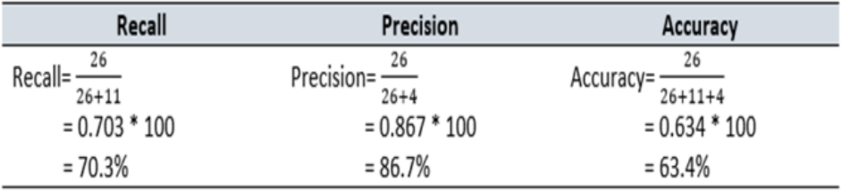

*Table 1A: The performances of VGG-16*

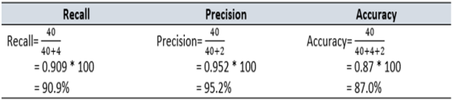

*Table 1B: The performance of ResNet50*

In paper [2], DL algorithms were applied to identify ASD patients from a large brain imaging dataset (ABIDE dataset), based solely on the patients’ brain activation patterns. They investigated patterns of functional connectivity that objectively identify ASD participants from functional brain imaging data, and attempted to unveil the neural patterns that emerged from the classification. Denoising auto-encoders were used to train the predictive model for better generalization. The deep neural network achieved a mean classification accuracy of 70% (sensitivity 74%, specificity 63%) from cross-validation folds, and a range of accuracy of 66% to 71% in individual folds. The SVM classifier achieved mean accuracy of 65% (sensitivity 68%, specificity 62%); while the Random Forest classifier achieved mean accuracy of 63% (sensitivity 69%, specificity 58%)

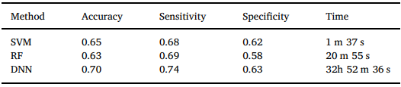

*Table 2: Comparison of DNN, RF and SVM trained on the entire dataset*

In paper [3], DL was used to extract data, which was then fed into an SVM classifier. The dataset was from the ABIDE database. A technique called SMOTE was used to reduce oversampling, and a tool called ATM was used for hyper-parameter tuning. The entire method is called Auto-ASD-Network. The network was able to achieve higher accuracies for 4 different datasets [See Table 3] and significantly improved the results for SVM classifiers.

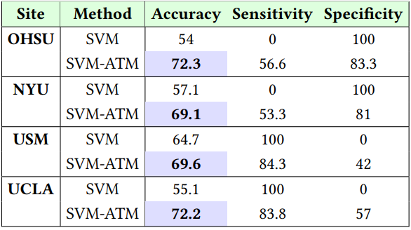

*Table 3: Performance comparison of traditional SVM and SVM optimized with ATM (SVM-ATM)*

In paper [4], they attempted to generate predictive models for toddlers using RF, NB and SVM classifiers. RF showed the best accuracy with 80.9% compared to 80% for NB and SVM [See Table 4A].  They also conducted an evaluation about the predicted performance of models based on different cortical features such as thickness (CT), surface area (SA) and regional average cortical volume (CV). They collected their own data from 85 participants aged 18-37 months, from which 46 were diagnosed with ASD. Their work confirmed that classification is significantly more accurate for CT compared to CV and SA. Models based on CT had 75% accuracy while CV and SA had 68% and 72% respectively. [See Table 4B] This may indicate that cortical thickness might be the most prominent feature of abnormal cortex in ASD.

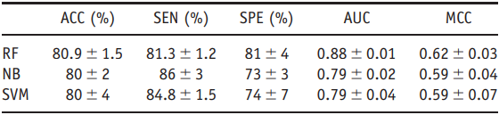

*Table 4A: Performance Metrics Comparison of Three Predictive Models*

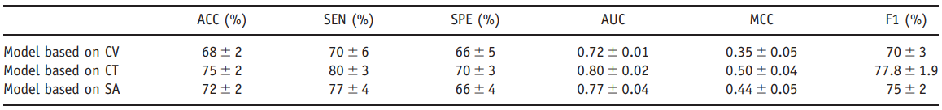*Table 4B: Performance Metrics for Three Features Generated by RF*

In paper [5], additional features- demographic and behavioral information- were augmented to the ABIDE data sets to improve the prediction of autism using sMRI (structural MRI). The classification was performed using three different techniques: Random Forest (RF), Support Vector Machine (SVM) and Gradient Boosting Machine (GBM). RF was used to find the effect of DB measures on classification accuracy since its performance was marginally better than that of the other two classifiers. The highest RF classification accuracy was 60% (sensitivity = 57%, specificity = 64). A significant positive correlation (r = 0.518, p-value = 0.048*) was observed between mean POA and ADOS for ASD subjects.

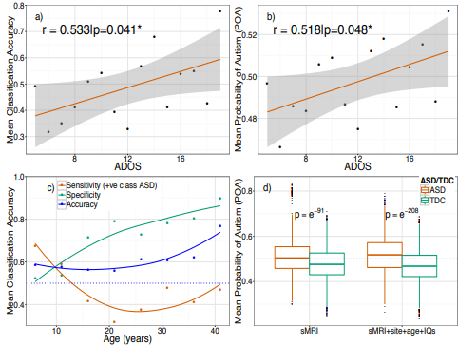

*Table 5: Effect of behavioral and demographic measures on classification accuracy*

In paper [6] they used a cross-species machine learning framework that used connectome-based features learned from a primate genetic model of autism and then built a classifier for diagnostic utility in humans. Nine core regions predominantly distributed in frontal and temporal cortices [see Figure 1] were identified in monkeys using group lasso algorithm and those were used as templates to construct the monkey-derived classifier that was used in the classification of human autism. The classifier based on these core regions achieved an accuracy of 61.31% on the human brain. Similarly, in the ABIDE-I data set, this group lasso algorithm identified four core regions. The classifier based on the four core regions achieved an accuracy of 60.40% (95% CI=52.04, 68.21), with a sensitivity of 53.33% (95% CI=40.10, 66.14), a specificity of 65.17% (95% CI=54.26, 74.76) in the classification.

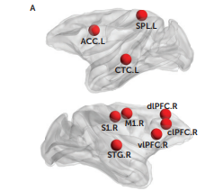

Figure : Nine identified core regions out of 94 nodes of the monkey brain

# project contributions

## Dataset

The dataset used in this project was from the ABIDE I database. It includes neuroimaging data of 1112 individuals, from which 539 individuals suffer from ASD and 573 are typical controls. The data is collected from 16 different international imaging sites, and are composed of structural and resting state functional MRI data along with an extensive array of phenotypic information. Only the fMRI data was used without including other demographic information, such as age, gender and IQ. This is because [2] has been used as the main reference for replication, and the paper’s goal was to solely rely on brain fMRI data for detecting ASD without being biased with other demographic information. The dataset before pre-processing has been shown below in Figure 2.

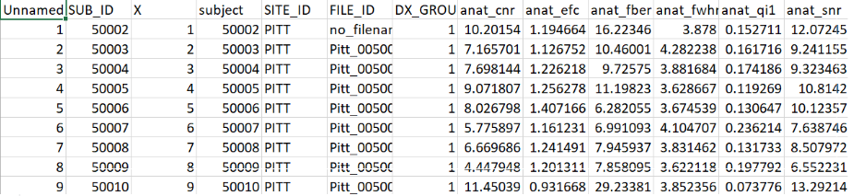

Figure 2: Original Dataset: ABIDE I Phenotypic File

The portion of the dataset used for the model is shown below in Figure 3.

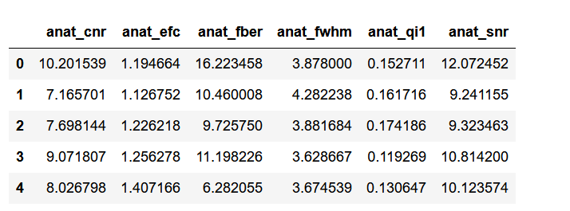

Figure : Pre-processed dataset

The results of the EDA have been displayed in the figures below. A heatmap has been plotted to show correlation between the various features in the dataset, shown in Figure 4.

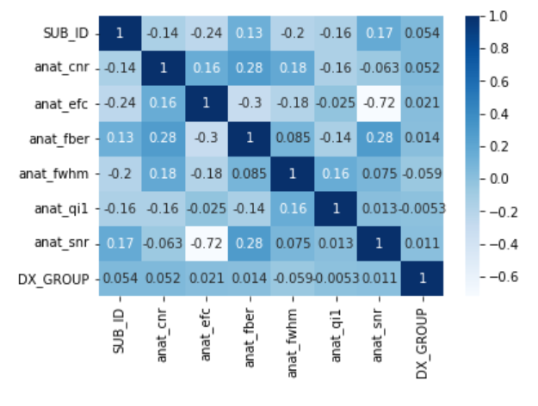

Figure : Heatmap between dataset features

A pie chart has been plotted to show the distribution of classification between ASD and TD diagnosed patients in Figure 5.

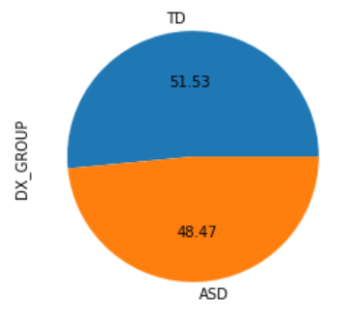

Figure : Pie chart of ASD and TD patients

## Algorithms Used

1. SVM Classifier: Support vector machines (SVMs) are a set of supervised learningmethods used for classification, regression, and detection of outliers. The advantages of using them are: Effectiveness in high dimensional spaces, and in cases where number of dimensions is greater than the number of samples.[9]
2. DecisionTree Classifier: Decision tree classifiers are **supervised machine learning models**. This means that they use pre-labelled data in order to train an algorithm that can be used to make a prediction. They work by splitting data into a series of binary decisions, which allow us to traverse down the tree based on these decisions, until we end at a leaf node, which will return the predicted classification. They’re generally faster to train than other algorithms such as neural networks, and can handle high dimensional data with high degrees of accuracy.[8]

The RandomForest classifier used in the research papers is an ensemble of decision tree classifiers trained on various sub-samples of the dataset and averaged to gain a better accuracy than any individual tree trained on the whole dataset. We have decided to use DecisionTree classifier in place of this algorithm to evaluate the accuracy of an individual decision tree without the bagging and feature randomness of RandomTree classifiers.

## Methodology

## We followed the standard procedure by starting the pre-processing and Exploratory Data Analysis (EDA) on the dataset. The dataset was imported and pre-processed to get rid of any null or incorrect values, and columns that were not required were omitted completely. The data was then visualized using EDA (Exploratory Data Analysis) in Jupyter Notebook to get a better understanding of our data set. It was then split for training and testing samples, and the models were fitted, then trained and tested on each respective portion. The Machine Learning algorithms implemented are SVM classifier and DecisionTree classifier. The results are then evaluated by plotting a confusion matrix and calculating the accuracy.

## Results of model replications

## The SVM classifier model correctly predicted 31 ASD cases from 128 and it correctly predicted 103 cases of Typically Developed (TD) out of 147. It incorrectly predicted 97 cases of ASD as TD and 44 cases of TD as ASD. It had an accuracy of 0.49 (49%), while paper [2] had an accuracy of 0.54 (54%). The confusion matrix and accuracy for the SVM classifier have been displayed in Figures 6 and 7 below.

## 

Figure 6: Confusion matrix for SVM classifier

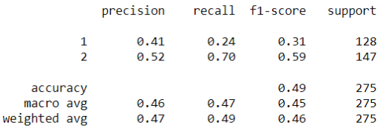

Figure 7: Accuracy for SVM classifier

## On the other hand, the Decision Tree classifier model correctly predicted 69 ASD cases out of  123 cases, and correctly predicted 84 TD cases out of 152. It incorrectly predicted 54 cases of ASD as TD and 68 cases of TD as ASD. It had an accuracy of 0.56. The Decision Tree classifier performed better at classifying ASD cases compared to the SVM classifier, and ultimately had the accuracy of 0.56 (56%). The confusion matrix and accuracy for the DecisionTree classifier have been displayed in Figures 8 and 9 below.

## 

Figure 8: Confusion matrix for DecisionTree classifier

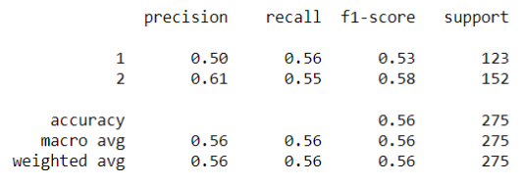

Figure 9: Accuracy for DecisionTree classifier

A table summarizing the results has been displayed below in Table 1.

Table 6: Summary table for model results

|  |  |  |  |  |  |  |  |
| --- | --- | --- | --- | --- | --- | --- | --- |
| Model | Precision (for ASD and TD) | | Recall (for ASD and TD) | | F1-score (for ASD and TD) | | Accuracy (overall) |
| SVM classifier | 0.41 | 0.52 | 0.24 | 0.70 | 0.31 | 0.59 | 0.49 |
| DecisionTree classifier | 0.50 | 0.61 | 0.56 | 0.55 | 0.53 | 0.58 | 0.56 |

These results are to be expected in a binary classification model, as it is difficult to have percentages above 50% without the data set being skewed towards certain values or without using any pipelines to optimize the performance. Both the results in the papers surveyed and for that of the models evaluated on this paper reflect this.

# conclusion

Individuals who fall under the Autism Disorder Spectrum display various behavioral patterns and characteristics, which is why it may be difficult to accurately detect it in many individuals just by using medical history, psychological evaluation, and clinical observation. The use of machine learning and deep learning models to identify patterns in the human brain that are associated with ASD act as supplementary evidence for the diagnosis of ASD.

In this paper, the overall goal of replicating models used in other experiments to detect ASD using computationally extensive algorithms has been achieved. We have used two machine learning models on the ABIDE I dataset- SVM classifier and DecisionTree Classifier. The evaluation metrics for these models are the overall accuracy, precision, recall and F1 score. The SVM classifier gave an overall accuracy of 47% (precision= 0.47, recall= 0.49, F1 = 0.46), approaching a similar accuracy to paper [2]. The Decision Tree classifier gave 56% overall accuracy (precision= 0.56, recall= 0.56, f1 = 0.56), similar to the accuracy of the RandomForest Classifier in [2]. In most papers, the calculated accuracies of ASD detection using Machine Learning algorithms were quite low due to the datasets used being relatively small and overfitting concerns.

##### References

[1]:  R. Nur Syahindah Husna, A. R. Syafeeza, Norihan Abdul Hamid, Y. C. Wong, R. Atikah Raihan. 22nd April, 2021. Functional Magnetic Resonance Imaging for Autism Spectrum Disorder Detection using Deep Learning.

[2]: Anibal Sólon Heinsfeld, Alexandre Rosa Franco, R. Cameron Craddock, Augusto Buchweitz, Felipe Meneguzzi. 30th August, 2017. Identification of autism spectrum disorder using deep learning and the ABIDE dataset.

[3]: Taban Eslami and Fahad Saeed. 2019. Auto-ASD-Network: A Technique Based on Deep Learning and Support Vector Machines for Diagnosing Autism Spectrum Disorder using fMRI Data.

[4]: Xiang Xiao, Hui Fang, Jiansheng Wu, ChaoYong Xiao, Ting Xiao, Lu Qian, FengJing Liang, Zhou Xiao, Kang Kang Chu, and Xiaoyan Ke. 2016. Diagnostic Model Generated by MRI-Derived Brain Features in Toddlers With Autism Spectrum Disorder

[5]: Gajendra J. Katuwal, Nathan D. Cahill, Stefi A. Baum, Andrew M. Michael. [2015 37th Annual International Conference of the IEEE Engineering in Medicine and Biology Society (EMBC)](https://ieeexplore.ieee.org/xpl/conhome/7302811/proceeding). The Predictive Power of Structural MRI in Autism Diagnosis.

[6] Yafeng Zhan, M.S., Jianze Wei, M.S., Jian Liang, Ph.D., Xiu Xu, M.D., Ran He, Ph.D., Trevor W. Robbins, Ph.D.. Zheng Wang, Ph.D. Am J Psychiatry 2021. Diagnostic Classification for Human Autism and Obsessive-Compulsive Disorder Based on Machine Learning From a Primate Genetic Model.

[7] Autism Spectrum Disorders. Stephen Brian Sulkes, Feb 2022.<https://www.msdmanuals.com/professional/pediatrics/learning-and-developmental-disorders/autism-spectrum-disorders>

[8] Decision Tree Classifier with Sklearn in Python. April 17, 2022.<https://datagy.io/sklearn-decision-tree-classifier/>

[9] Support Vector Machines. <https://scikit-learn.org/stable/modules/svm.html>